‘ 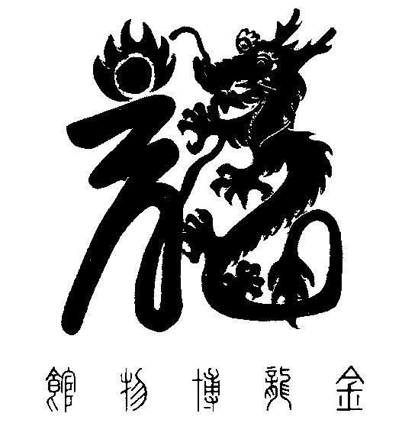

National Chinese Museum of Australia Ltd. T/A

**GOLDEN DRAGON MUSEUM**

**YI YUAN GARDENS & GUAN YIN TEMPLE**

Dai Gum San

1-11 Bridge Street Bendigo VIC 3550 / PO Box 877 Bendigo VIC 3552

**T** + 61 3 54 415044 / **E** info@goldendragonmuseum.org

**W** www.goldendragonmuseum.org

**ABN 41 309 670 936**

21 November 2024

EMBARGOED UNTIL 11.00AM MONDAY 25 NOVEMBER 2024

MEDIA RELEASE

Fascinating multimedia project launched.

To celebrate this auspicious Year of the Dragon local multimedia artist and educator Ivan Sun presents his latest project at

Golden Dragon Museum.

**‘House of Loong’**

Delivered through an iPad application, 'House of Loong' tells the story of why three generations of Imperial Processional Dragons (Loong, Sun Loong, and Dai Gum Loong) were commissioned and brought to Bendigo. It explains how the local tradition of parading Dragons during Easter has remained unbroken for over 130 years, a practice unique in the world.  
  
‘House of Loong’ has three components: a short documentary; an audio experience; and an interactive quiz with original 3D animations bringing to life the iconic 1901 photograph of Loong parading in Melbourne at Australia's Federation celebrations.

Launched by Ms Dongyuan Liu, Deputy Consul General of the People’s Republic of China in Melbourne, ‘House of Loong’ is the latest addition to the Museum’s permanent exhibition, presenting a fun and contemporary way of learning some of the history of Bendigo’s three famous Dragons.

This Project joins other recent initiatives at the Museum that work to engage with and build its growing audiences including the new Golden Dragon Museum Auslan Self-Guided Tour and the Origins brochure being available now in Spanish and Hindi.

EMBARGOED UNTIL 11.00AM MONDAY 25 NOVEMBER 2024

Home to the largest and most significant collection of Chinese heritage and cultural objects in Australia, the Museum is proud to have worked with Ivan Sun to deliver this dynamic and creative digital installation.

Attributable quotes

Deputy Consul General Liu said: ‘Dragons have played a fascinating central role in China’s culture for thousands of years. In this, the Year of the Dragon, it is exciting to see ‘House of Loong’ being given a special place in the Museum, allowing visitors of all ages and backgrounds the opportunity to learn more about Bendigo’s three mighty Dragons.’

Ivan Sun said: ‘As an artist and educator it is important to me that the audience finds ‘House of Loong’ not only an informative experience, but also emotionally moving. The three components of the Project are designed to complement each other allowing visitors to engage with new technology to explore and learn about China’s very ancient culture and how the Dragons have become part of Bendigo’s history and identity.’

Hugo Leschen, Chief Executive Officer, Golden Dragon Museum said: ‘Golden Dragon Museum is an enthusiastic collaborator with other creative institutions and artists and is pleased to have partnered with Ivan Sun in his latest work ‘House of Loong.’ Bendigo’s three Imperial Processional Dragons are central to the Museum’s collection of 30,000 objects and ‘House of Loong’ is a wonderful example of how ancient stories and cultures can be brought to life and shared through modern technology and fresh eyes.

Ivan Sun and the Museum particularly thank everyone who has supported this project, especially the Australian Government, Regional Arts Australia and Regional Arts Victoria.’

**END**

**Launch and Media Call**

The media is invited to join other guests as Ms Dongyuan Liu launches ‘House of Loong’ at **11.00am, Monday 25 November**, at Golden Dragon Museum.

Ivan Sun and Hugo Leschen will be available for interviews and photographs.

Media enquiries: Please contact Hugo Leschen, Chief Executive Officer, Golden Dragon Museum 0417 100 229.

House of Loong was made possible by the Australian Government’s Regional Arts Fund, which supports the arts in regional and remote Australia. This project is supported by the Australian Government’s Arts and Cultural Development Program, Regional Arts Australia and Regional Arts Victoria.