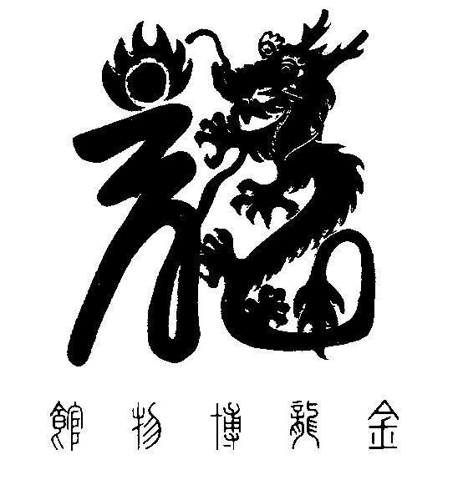

National Chinese Museum of Australia Ltd. T/A

**GOLDEN DRAGON MUSEUM**

**YI YUAN GARDENS & GUAN YIN TEMPLE**

Dai Gum San

1-11 Bridge Street Bendigo VIC 3550 / PO Box 877 Bendigo VIC 3552

**T** + 61 3 54 415044 / **E** info@goldendragonmuseum.org

**W** www.goldendragonmuseum.org

**ABN 41 309 670 936**

EMBARGOED UNTIL 6.00AM FRIDAY 22 NOVEMBER

MEDIA RELEASE 20 November 2024

Exciting new exhibition opens at the Golden Dragon Museum

‘In Focus: Images of Bendigo’s Dragons 1895 – 2024’

23 November 2024 – 23 February 2025

A wonderful temporary exhibition marks the end of the Year of the Dragon and showcases Bendigo’s most iconic emblem, the Chinese Dragon.

Showing more than 60 images selected primarily from Golden Dragon Museum’s outstanding collection of over 30,000 objects, ‘In Focus: Images of Bendigo’s Dragons 1895 – 2024’ traces the history of the many dragons that have featured in Bendigo and further afield since the late 19th century. A highlight of the Bendigo Easter Festival, the Dragons have also been seen and enjoyed by people across south-eastern Australia for decades. Loong, for example, was a feature of the parades held in Melbourne celebrating the Federation of Australia in 1901.

As this Year of the Dragon draws to a close, this exhibition showcases the many ways in which the history of Bendigo’s dragons has been recorded in images over the past 130 years. Displayed in the exhibition are photographs, slides, stereoviews, videos, and illustrations that depict these beautiful dragons in all their wonder.

From professional photographers and newspapers to ‘happy snaps’ and home videos, there is a wealth of imagery through which we can witness their history.

Quotes attributable to Doug Lougoon, Chair, Golden Dragon Museum:

*‘Many people know our three wonderful Imperial Processional Dragons. Loong, who paraded from 1901 until 1970. Sun Loong who paraded from 1970 until 2019 and Dai Gum Loong, our current Parading Dragon. These three are justifiably famous and loved by thousands.*

*However, the history of Bendigo’s dragons goes well beyond only these favourites. From Duck Bill and Moon Face, two long gone dragons now only known to us through photographs, through to lesser known and infrequently seen dragons, Bendigo’s association with these magnificent creatures is deep and profound.*

EMBARGOED UNTIL 6.00AM FRIDAY 22 NOVEMBER

*Initiatives such as ‘In Focus’ are only possible with support, and I especially thank the City of Greater Bendigo for their support of our Temporary Exhibition Program through their Community Grants Program.*

*‘In Focus’ is an opportunity to relive old memories and happy times. However, this wonderful exhibition closes on 23 February 2025 so be quick to see it!’*

**END**

Image caption:

Over 60 images of Bendigo’s amazing dragons are included in Golden Dragon Museum’s latest temporary exhibition ‘In Focus: Images of Bendigo’s Dragons 1895 – 2024’ Current 23 November – 23 February 2025

Photo credit: Tyrone Jack

Media inquiries:

Hugo Leschen, Chief Executive Officer, Golden Dragon Museum M: 0417 100 229

