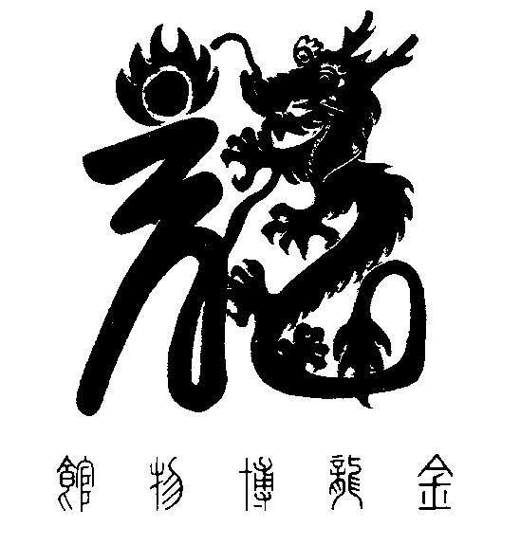

National Chinese Museum of Australia Ltd. T/A

**GOLDEN DRAGON MUSEUM**

**YI YUAN GARDENS & GUAN YIN TEMPLE**

Dai Gum San

1-11 Bridge Street Bendigo VIC 3550 / PO Box 877 Bendigo VIC 3552

**T** + 61 3 54 415044 / **F** + 61 3 54 433127

**E** info@goldendragonmuseum.org / **W** www.goldendragonmuseum.org

**ABN 41 309 670 936**

**Expressions of Interest**

**Company Secretary (Voluntary)**

**NATIONAL CHINESE MUSEUM OF AUSTRALIA LTD.**

**T/A GOLDEN DRAGON MUSEUM**

**Position description**

* **Board Meeting Frequency:** Bi-monthly
* **Location:** Bendigo
* **Organisation Type:** Not for profit
* **Position Summary:** National Chinese Museum of Australia Ltd. (NCMA) is seeking an experienced and highly organised Company Secretary to join our team. The Board Secretary will be responsible for managing the administrative functions of the board and ensuring that all board meetings run smoothly and efficiently. The preferred person will have excellent communication and organisational skills, as well as strong attention to detail.

**ABOUT National chinese museum of australia ltd.**

The **Golden Dragon Museum** 金龙博物馆 is situated in the City of Greater [Bendigo](https://en.wikipedia.org/wiki/Bendigo). The museum is dedicated to the culture and [history of Chinese Australians](https://en.wikipedia.org/wiki/History_of_Chinese_Australians), particularly in the region. Built on the historical site of Bendigo's [Chinatown known as Dai Gum San Precinct,](https://en.wikipedia.org/wiki/Chinatowns_in_Australia) the museum's precinct also includes Yi Yuan Classical [Chinese Gardens](https://en.wikipedia.org/wiki/Chinese_Gardens) and a temple to [Guan Yin](https://en.wikipedia.org/wiki/Kuan_Yin).

The Golden Dragon Museum was founded to protect, preserve, and teach the history of the Chinese in Bendigo. It houses a large and internationally significant collection of Chinese processional regalia from the [Bendigo Chinese Association](https://en.wikipedia.org/w/index.php?title=Bendigo_Chinese_Association&action=edit&redlink=1). These formed the basis of the museum's collection. The collection has grown significantly since its inception in 1991 with both small and large donations and acquisitions.

The organisation’s goal is to transition the Golden Dragon Museum to become the National Chinese Museum of Australia – a Redevelopment Project, to construct a stunning, landmark building/extension that complements the positioning of the Museum as a national cultural centre for Chinese Australian heritage.

1

**Key responsibilities:**

* Support the Board with monitoring compliance with statutory obligations.
* Schedule and organise all board meetings and related events, including sending out invitations, preparing agendas, and ensuring that all necessary documentation is available for board members.
* Take accurate minutes of board meetings, capturing board decisions and resolutions, and ensure they are promptly distributed to all board members.
* Manage all board correspondence, including drafting letters and responding to inquiries from board members and external stakeholders.
* Maintain accurate and up-to-date records of all board activities, including meeting minutes, attendance records, and other relevant documents.
* Assist the board chair with the development and implementation of policies and procedures, as well as other special projects as needed.
* Support the Board to ensure they are aware of their legal and ethical responsibilities.
* Maintain confidentiality and discretion in all board-related matters.

**Qualifications:**

* Experience as a company secretary or in a similar administrative role.
* Strong written and verbal communication skills.
* Excellent organisational and time management skills.
* Proficiency in Microsoft Office and other relevant software programs.
* Ability to maintain confidentiality and discretion.
* Knowledge of Golden Dragon Museum or the Cultural and Arts Sector is preferred but not required.

The Company Secretary plays a critical role in ensuring the effective operation of the board of directors and the organisation. By monitoring compliance with statutory obligations, the Secretary helps to protect the organisation from legal and reputational risks and ensures that the board operates in a transparent and ethical manner.

The Company Secretary will work closely with the Board Chair, CEO, and other members of the Board of NCMA.

If you are a highly organised individual with excellent communication skills and a passion for supporting the operations of a board of directors, we encourage you to apply for this rewarding opportunity.

**Interested?**

To submit your interest with any relevant documentation please email the [chair@goldendragonmuseum.org](mailto:chair@goldendragonmuseum.org) by Friday November 17th, 2023.