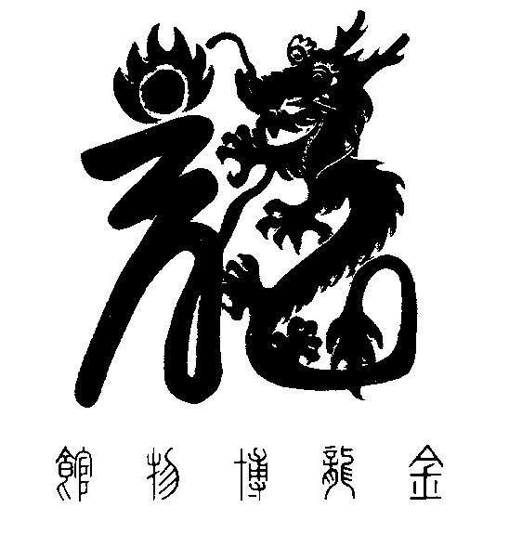

National Chinese Museum of Australia Ltd. T/A

**GOLDEN DRAGON MUSEUM**

**YI YUAN GARDENS & GUAN YIN TEMPLE**

Dai Gum San

1-11 Bridge Street Bendigo VIC 3550 / PO Box 877 Bendigo VIC 3552

**T** + 61 3 54 415044 / **F** + 61 3 54 433127

**E** info@goldendragonmuseum.org / **W** www.goldendragonmuseum.org

**ABN 41 309 670 936**

**Expressions of Interest**

**Board Members x 2 (Voluntary)**

**NATIONAL CHINESE MUSEUM OF AUSTRALIA LTD.**

**T/A GOLDEN DRAGON MUSEUM**

**Position description**

* **Board Meeting Frequency:** Bi-monthly
* **Location: Bendigo**
* **Organisation Type: Not for profit**
* **Position Summary:** National Chinese Museum of Australia Ltd. (NCMA) is seeking passionate and experienced individuals to join our Board. As a Board Director, you will have the opportunity to contribute to our organisation's purpose, vision, and governance. In this Director role, you will bring your skills, experience, and expertise to support the organisation's growth and development. Directors should be strong communicators, have a genuine interest in the Cultural and Arts Sector.

**ABOUT National chinese museum of australia ltd.**

The **Golden Dragon Museum** 金龙博物馆 is situated in the City of Greater [Bendigo](https://en.wikipedia.org/wiki/Bendigo). The museum is dedicated to the culture and [history of Chinese Australians](https://en.wikipedia.org/wiki/History_of_Chinese_Australians), particularly in the region. Built on the historical site of Bendigo's [Chinatown known as Dai Gum San Precinct,](https://en.wikipedia.org/wiki/Chinatowns_in_Australia) the museum's precinct also includes Yi Yuan Classical [Chinese Gardens](https://en.wikipedia.org/wiki/Chinese_Gardens) and a temple to [Guan Yin](https://en.wikipedia.org/wiki/Kuan_Yin).

The Golden Dragon Museum was founded to protect, preserve, and teach the history of the Chinese in Bendigo. It houses a large and internationally significant collection of Chinese processional regalia from the [Bendigo Chinese Association](https://en.wikipedia.org/w/index.php?title=Bendigo_Chinese_Association&action=edit&redlink=1). These formed the basis of the museum's collection. The collection has grown significantly since its inception in 1991 with both small and large donations and acquisitions.

The organisation’s goal is to transition the Golden Dragon Museum to become the National Chinese Museum of Australia – a Redevelopment Project, to construct a stunning, landmark building/extension that complements the positioning of the Museum as a national cultural centre for Chinese Australian heritage.

**Key responsibilities**

* Attend Board meetings and respective Board committees.
* Actively participate in Board discussions and decision-making processes
* Provide strategic guidance and direction to the organisation, including the development of the organisation's strategic direction.
* Ensure organisational compliance with all legal, statutory and regulatory requirements.
* Monitor and evaluate the organisation's performance and provide constructive feedback to CEO.
* Act as an ambassador for the organisation, promoting its work and values to the community.

**Qualifications**

* Strong commitment to the organisation's purpose and vision
* Experience serving on non-profit Boards or equivalent leadership roles in committees.
* Excellent communication and interpersonal skills
* Strong analytical and problem-solving skills
* Strategic thinking and planning abilities
* Willingness to commit to a minimum of three years of service on the Board.
* Understanding of regulatory requirements of NFP organisations/Company Limited by Guarantee.

**BOARD DIRECTORS**

The NCMA Board consists of up to nine (9) highly experienced volunteer Directors.

**SKILL BASED BOARD AND SKILL GAPS**

NCMA is a skills-based Board. The Board requires a mix of skills and experience to work as a well‐rounded team, to govern NCMA both now and into the future. Based on skill assessment the following skill gaps were identified that could strengthen the NCMA Ltd. Board:

* Corporate law
* Financial, Audit and Risk management technical expertise (CA/CPA Qualified Accountant)
* Expertise in Government relations, stakeholder management, and advocacy
* Community engagement and public relations

NCMA is also actively seeking to strengthen diversity on the Board considering:

* Culturally and linguistically diverse
* Aboriginal/Torres Strait Islander
* Gender
* Under 40/Emerging Leader

**Interested?**

To submit your interest with any relevant documentation please email the [chair@goldendragonmuseum.org](mailto:chair@goldendragonmuseum.org) by Friday November 17th, 2023.